
Africa have a large concentration of tribal people. However, tribals are interspersed everywhere -from North American Indians (including Alaskan Eskimos) to Australian Aborigines, New Zealand Maoris and many Nomadic people who roam desert or jungle areas in remote regions of the world.
The Tribal World: Culturally
Typically, tribal people are isolated from the rest of mankind because of cultural and linguistic barriers as well as sheer geographical remoteness. Isolated as they are from law enforcement and medical services, they face danger from their own tribal in-fighting, epidemics beyond the ability of their folk healers as well as a variety of natural calamities. Unable to survive on their own, many tribal communities pass quietly into extinction.
If they manage to survive the hardship of isolation from the outside world, tribal people then are quickly thrust into the fast-paced 21st century and must contend with the opposite hardship of a rapidly encroaching Western civilization with all of its commercial and political intrusion by larger and more technologically advanced people. During this encroachment phase, tribals face danger from prejudice, exploitation, and new diseases for which they have very little immunity.
It is a fact of the 21st century existence that tribal people in many developing nations are sprinting towards urbanization. This modernization of the people often causes cultural chaos and a de-tribalizing of the upcoming generation. Hordes of tribal children are now being reared in cities where eventually they will lose their intimate ties with the “home” village. Too often they grow up without land, property rights and no real use for their tribal language. Cultural identity is obtained primarily through land and language and this is disappear

“exhort in sound doctrine and refute those who contradict” (Titus 1:9)
about 4,000 of these tribes are classified as having been reached with the gospel.
Tribal peoples are not easily categorized. Cultural diversity among tribes is enormous, encompassing a broad range of peoples from headhunting cannibals to university educated intellectuals.
I believe that tribals are one of the most difficult of all the people blocks to reach. Why?
The Proliferance of Tribal Languages. Approximately 5,100 languages are spoken among 6,000 tribes. One difficulty with tribal languages is that very often they are not dialects of one another. In many cases, they are totally unrelated languages.
Tribal Size. Using Islam as a reference point, the 5,500 Muslim groups are relatively large in their populations –over 200,000 on average. That is roughly ten times the average size of an unreached tribal group.
No Common Denominator of Faith. Muslims refer to the Koran and The Five Pillars of Islam as an essential rule of faith practiced by Muslims regardless of where they reside in the world. Unlike orthodox Islam or traditional Hinduism, Tribals by contrast do not have an established universality of faith. Though they do share a familiar spiritistic worldview, animistic beliefs differ significantly from tribe to tribe with each village applying its own variation of tribal religion.
Tribal Locations. The centralized strongholds of Islam, Hinduism and Buddhism are tucked neatly within the 10/40 window. The 10/40 window is the large area between the latitudes 10 and 40 degrees north of the equator and between the Atlantic and Pacific Oceans. This geographic window encompasses the vast majority of the 2.8 billion Muslims, Hindus and Buddhists who are still unreached with the gospel. However, it is impossible to describe definitively the location of tribal people because they are situated all over the globe in virtually every country. Places like the island of New Guinea, South America and

The Tribal World: Statistically
There are many ways to analyze the people of the world.
Geographically, we can say that the world’s 6.5 billion people inhabit the seven continents and thousands of islands all across the seven seas. But that doesn’t tell us much.
Religiously, we may categorize the world’s unreached population into five major people blocks: Muslims, Hindus, Tribals, Buddhists and Chinese.
Breaking this down further, there are approximately 27,000 people groups who live within the five people blocks. Roughly 13,000 of these peoples are still considered to be unreached; they remain without a meaningful presentation of the gospel and a viable church among their residents.
Of these 13,000 unreached peoples:
5,500 are among Muslims
3,200 are among Hindus
2,000 are among Tribals
1,500 are among Buddhists
300 are among Chinese
200 are among Jews
200 are among Others (Confucian, Sikhs, Spiritists, etc. )
100 are among Non-Religious (Secularists).
These statistics are educated estimates and the numbers are changing all the time, but it does help us to gain some understanding about the world’s unreached peoples.
There are approximately 6,000 animistic tribes worldwide, representing as many as 200 million individuals. Presently, only

CHRISTIAN DEBATER GUIDE VOLUME 5, NUMBER 4
OF AUSTIN, TEXAS
TO EVERY TRIBE WITH JESUS (Part I)
(continued on page 3)
David Sitton
Christian missionary, founder of To Every Tribe Ministries, author, speaker, director of Center for Pioneer Church Planting.

Christian Debater Guide
Answers In This Issue
To Every Tribe with Jesus…………………...1
Ministry Update…........………………………...6
Order Form………………..…….……..…………..7 Letters From the Frontline......................8

CHRISTIAN DEBATER GUIDE

Publisher
CHRISTIAN ANSWERS OF AUSTIN, TX
P.O. Box 144441
Austin, TX 78714
Phone (512) 218-8022
Director/Editor
Larry Wessels
Director of Research
Steve Morrison, Ph.D.
E-mail Address:
cdebater@aol.com
Websites:
www.biblequery.org
www.historycart.com
www.muslimhope.com

Our ministry is “exempt from federal income tax under section 501 (a) of the Internal Revenue Code as an organization described in section 501 ( c) ( 3 ) by the Internal Revenue Service”. Donations to our ministry are tax deductible, therefore those who contribute will receive a donation receipt good on your US income tax. This applies to donations only, not sales. We are legally registered in the state of Texas.
2
THOUGHTS FROM THE DIRECTOR

I’ll never forget, oh it must have been back in 1982, I had just
finished witnessing to three Mormon missionaries who had been
over to my house for about two hours before they had to leave. Not
long after they left I got a visit from a real missionary named David
Sitton. This dear brother came by to fellowship for a little while and
we sat around discussing all our evangelism activities.
David Sitton, I presume, was about the closest thing to Dr.
Livingston I knew or had heard about. Here’s a guy who cuts through jungles with a machete to get to a tribe of head-hunting, animistic natives in Papua New Guinea to share the Gospel of Jesus Christ with them. Here’s a guy who will paddle down a crocodile infested river just to administer aid, comfort, and of course the Gospel, to strangers, speaking a foreign tongue, who are engulfed in idolatry, witchcraft, sorcery, and spiritism. Here is a guy who God has used mightily in the mission field. To be around him was simply an honor.
But the most amazing thing about brother Sitton was not all his obvious accomplishments in missions but what he said to me the night he came by to visit. The reason I’ll never forget that night is because of what David told me without even flinching. He told me that he had more respect for someone like me, just a simple preacher, evangelist and teacher, than himself! Naturally, I thought he was just doing the typical “Christians need to be humble and self-effacing” routine to control pride but I was dead wrong. David, who is humble, was dead serious.
David explained to me that he had great respect for Biblical evangelists in America because their job of evangelism was tremendously more difficult here in the United States than it was for him in the jungles of Papua New Guinea. David said that Americans have become hardened to the Gospel and reaching them for Christ is tough while among unreached tribal peoples, the preaching of the Gospel is received with joy and the power of the Holy Spirit is much more evident. David was basically saying it was easier to preach to a bushman than to a sophisticated American man in a three piece suit. Amazing! I Corinthians 1:17-31 says it all. Amen.
Larry Wessels
The Gospel in Brief
There is one, and only one, eternal, true, holy God (Father, Son, and Holy Spirit, Matt 28:19). He created everything by His word. God has told us the truth about Himself in the word He has given us, the Bible, which He commands us to obey. God is compassionate and just to all. God is pure and Holy; sin is destroyed in His presence (Numbers 14:18). However, we have all sinned, falling short in the evil we do, and the good we fail to do. Yet our problem is not just what we do, but also who we are; we are selfish, corrupt, and estranged from God. Because God is just, He will punish sin impartially, yet God still bestows his love to all men. So our Savior, Jesus, the only begotten Son of God (the God-man, John 1:1,14), was graciously sent to suffer and die on the cross for our sins and to purify us from all unrighteousness by the sacrifice of His body and blood. He was born of the virgin Mary, lived a sinless life, and was physically raised from the dead and ascended into heaven. Jesus will physically return to judge the world. God commands everyone to repent and to believe in Him. God’s Spirit lives in each of us who believe in Him to guide us into truth, convict us of our sins, and to work in us to sanctify us to live a more holy life, pleasing our Lord. God’s children will dwell forever with God, and those who reject Jesus will suffer eternal torment. There is no other way for anyone to come to God except through Jesus (Jn. 14:6). Please do not depend on anyone else, your own efforts, your religion, but simply put your faith in Christ our Master. So as Rom. 10:9 says, ”That if you confess with your mouth ,”Jesus is Lord,” and believe in your heart the God raised him from the dead, you will be saved.” You are urged not to despise God’s mercy but call out to the Lord and trust ONLY in Him.
(See also Acts 10:36-43)
THE GOSPEL IN BRIEF
WHAT IS CHRISTIAN ANSWERS ?

Our ministry name is derived in part from Peter 3:15 which states, “But in your hearts set apart Christ as Lord. Always be prepared to give an answer to everyone who asks you to give the reason for the hope that you have.” (KJV). This is the goal of Christian Answers in an increasingly anti-Christian society here in America and throughout the world; giving answers and reasons why the Christian faith can be trusted and believed.
The Biblical commands to “fight the good fight of faith” (I Tim. 6:12), to be “set for the defense of the gospel” (Phil. 1:17), to “earnestly contend for the faith which was once delivered unto the saints” (Jude 3), to “be able both to exhort in sound doctrine and to refute those who contradict” (Titus 1:9), to “put to the test those who call themselves apostles, and they are not” (Rev. 2:2), to “Beware of false prophets, who come to you in sheep’s clothing, but inwardly are ravenous wolves.” (Matt. 7:15), to “examine everything carefully; hold fast to that which is good” (I Thess. 5:21),” with gentleness correcting those who are in opposition, if perhaps God may grant them repentance leading to the knowledge of the truth” (2 Tim. 2:25), to follow the example of Paul and Apollos who “vigorously refuted the Jews in public debate, proving from the Scriptures that Jesus was Christ.” (Acts 18:28). These are but a few of the marching orders for the call to ministry, discernment and evangelism.
The inerrant Word of God (2 Tim. 3:16-17) whereby the gospel is preached, which is “the power of God unto salvation to everyone that believeth” (Rom. 1:16), is the weapon of our evangelism. As Hebrews 4:12 states, ”For the word of God is living and active. Sharper than any double-edged sword, it penetrates even dividing soul and spirit, joints and marrow: it judges the thoughts and attitudes of the heart.” This is the evangelical missionary methodology of Christian Answers— to bring the Biblical perspective to a culture that is almost completely ignorant of it; to bring Christian truth, Christian answers to those who, as the prophet Isaiah said, have made “lies...and falsehood” their refuge (Isa. 28:15); to smash lies and falsehoods with the “hammer” of God’s word (Jer. 23:29); see also Proverbs 30:5-6, Psalm 138:2b, Isaiah 40:8, John 5:39-47, I Cor. 14:37, and Acts 17:11.
Christian Answers utilizes all outreach that God allows us including television, radio, audio CDs, video DVDs, speaking engagements, and the printed page. The materials we have been able to produce have been used by churches, Bible teachers, Christian apologists, laymen and others as well as those seeking life in Christ.
We are not afraid to stand up for Jesus Christ in public forums or wherever the Lord leads. Of course this type of ministry is not for the faint of heart and very often leads to the same type of suffering and persecution that we find in the book of Acts. But as the old saying goes, “one life will soon be past, only what’s done for Christ will last,” and as Paul said, “I press toward the mark for the prize of the high calling of God in Christ Jesus.” (Phil. 3:14), knowing this mortal life is short and God’s eternity is only a moment away for all.


3
Christian Debater Guide
ing as youngsters are not even learning their tribal tongues, using English and various trade languages instead. When language and land are lost, then tribal custom becomes obsolete, oral histories and legends are forgotten and finally their cultural heritage is obliterated, leaving them as strangers in their own countries. These tribal people will either assimilate into other larger tribes or topple into extinction altogether.
The Tribal World: Historically
Are tribal people strictly monotheistic in their beliefs about the one, true, supreme God?
Historically, in the beginning, tribal people did believe in a supreme God. In scripture we see that God revealed Himself to Adam and Eve as both Creator and Redeemer (Gen. 1:27; 3:15, 21). There simply was no other deity to consider. And this basic knowledge of God was passed down through the generations. However, as time passed and the peoples were scattered throughout the earth after Babel, man in his fallen state distorted this knowledge of God and in many cases began to deny it altogether (Romans 1:18-32).
It is noteworthy that even the ancient Hebrews of Abraham’s day were not strictly monotheistic. Many passages confirm that the Hebrew fathers worshipped multiple deities (Psalm 106:34-39). And the Decalogue explicitly details God’s jealousy when Israel bowed before the idols of the nations (Ex. 20:2-6). The Old Testament is a textbook on the practice of animism. We read about the pagan gods Dagon, Chemosh, Molech, Tammuz and Bel. There are confrontations with fertility cults, heathen sacrifices, worship of the smooth round stones of the valley, and the national worship of war gods. Even among the Israelites we see them perform rites in the fields, by the wayside, in the groves and in the temples. Divination, necromancy and sorcery are also frequent topics of scripture.
But as Yahweh revealed Himself more personally to them, these already existing allegiances became subservient to the “primary allegiance” reserved only for Yahweh. Even so, it is not until after the Exodus that we find a type of monotheism that we are more comfortable with (Joshua 24:2, 14-15).
E.B. Idowu uses the term “diffused monotheism” rather than polytheism to describe the African concept of God. This is a belief in one true God who manifests Himself through lesser gods who are emissaries of the supreme God.

Tribes began with a belief in one, true, God. It is important to observe that many tribal people held to a belief in a supreme being long before Christian missionaries arrived with their concept of God. Many tribal stories and legends testify to that fact. At the same time, this supreme God has become distant to them. The everyday experience of animistic peoples is focused upon the spirits that live everywhere and influence everything. Because of this immediate preoccupation of trying to co-exist with evil spirits and ancestral deities, many tribes have forgotten about the supreme God altogether.
Are tribal people strictly monotheistic? The real answer is both yes and no. Some tribes have a semblance of memory about the one, true God and some do not. For more discussion about this, I encourage you to read Appendix B, “You and the Vanishing Tribes”, from my book.

Though the flicker of gospel light has been virtually extinguished among many peoples, it is a fact of missions history that tribal peoples have been wonderfully receptive when the gospel is presented to them.
John Stott writes, “The great mass movements into the church have, generally speaking, involved people of broadly ‘animistic’ background. By comparison, very few of those who have inherited one of the major culture-religions-Hindus, Buddhists, Jews, Muslims and Marxists –have been won to Christ.” For example, when Adoniram Judson died after thirty-seven years of labor in Burma, he left only one hundred converts from Buddhism but seven thousand from the animistic Karens.

Culture Clash! Western and Tribal World Views in Contrast
“If you want to be a missionary to China, plan on wearing a ‘learner’s permit’ around your neck for the first ten years.” –Watchman Nee
“Pioneer church planning is at least as complex as brain surgery.”–Phil Elkins

These are statements born out of gut-wrenching exasperation with the exotic cultures and languages of unreached peoples.
In the summer of 2002 a handful of us stood on the high point of a mountain range overlooking the Coicoyan region of Oaxaca, Mexico. This was our first visit to the Coicoyan people; a tribe of 25,000 people and only one known believer.
Standing on the edge of Coicoyan was an awesome and excruciating experience. Initially, there was the exhilaration of knowing Christ and having in our possession the eternal gospel that brings eternal life to those who will believe. But the joy of having the message was quickly replaced with awful frustration that we didn’t have the slightest idea how to translate the message into their cultural ways of thinking. We didn’t know a single word of their Mixteco language, let alone any useful understanding of their complex culture.
We made a commitment that day; that we will see to it, over the long haul of our lives, to do whatever it takes to get the gospel established among these dear people. But this is a promise whose fulfillment will only be realized over many years of grappling with language and culture learning and faithfully living out the gospel among them.
Acquiring language and cross-cultural proficiency is grueling work. And it’s a lifelong endeavor. Yet, effective ministry among animistic peoples is impossible without a thorough understanding of the people we want to reach.
I believe it is essential to fully grasp the implications of our own cultural traits and values first, before we can begin to understand, appreciate and identify with a foreign culture.
The following two outlines compare Western and Tribal worldviews that reveal a culture clash of deep proportions.
The Western World View
American Culture-A Sketch
1. The core of American Culture has its origins in Western European culture.
Language –English
Legal system derives from English law.
Democratic political system comes from France and England.
Justice is punitive, based on objective truth.
Majority rule and written regulations are the means of formulating laws.
Technology is from Europe. All of us have been conditioned by it.

2. The American Character

Christian Debater Guide
A. Originated in Europe but was subsequently influenced by life on the frontier, open spaces, virgin wealth, and “limitless” resources.
B. Rooted in ideas of independence, freedom, and rugged individualism.’

3. We have a strong agrarian tradition. But we are not highly urbanized with large segments of society being employed by large, impersonal institutions.
4. Because of our high standard of living and technology, we live longer than our ancestors.
5. There is surprising conformity in language, diet, hygiene, dress, basic skills, land use, community settlement, recreation, and education systems.
6. We have a relatively narrow opinion range because of our efficient communication and education systems.
7. Our status differences are based mainly on occupation, education and financial worth.
8. The basic American kinship unit is the nuclear family (though weakening).
Marriage relationships are fluid.
Old people and unmarried adults usually live apart from their kin.
9. The general education level is high.
10. The moral tone of the country is heavily Judeo-Christian. Formal religion is compartmentalized.
11. Sex sins and sins of violence are the greatest sins.
B. American Spirituality
Our religious tradition is heavily Judeo-Christian (Protestant).
Life is compartmentalized into the spiritual and secular. A classic illustration of this is that, in the Western mind, “professionals” in religion do their religion as “work” while the “non-professionals” do theirs as “play.”
Most people are not anti-religious, but merely indifferent.
Western society has been demystified. Our pursuit of “rationality” in all areas of life has led to incredible advances in science. But there has also been the corresponding loss of the sense of the supernatural.
Americans most often affirm that all there is to life is what can be seen and experienced with the physical senses. We draw deep lines between what is “real” and what is “supernatural.”
Furthermore, spirits are not real because they cannot be perceived by man’s natural senses.

4
c. Natural disasters such as earthquakes, hurricanes etc., as well as sickness, disease, war, accidents, and unexpected death are dealt with by giving scientific explanations of how they occurred. In many cultures there is no natural-versus-supernatural dichotomy. The supernatural directly involves the natural. That is why our preaching and teaching seem to have little relevance to their daily life. We explain sickness scientifically, on the basis of germs, nutrition, and related factors. Most cultures explain sickness through their belief in curses, the evil eye, witchcraft, or karma, which is all set against them.
Example: A man is killed in a car accident. The important question for the American is, “How did it happen?” Investigation shows that it was caused by poor brakes on the car. Using cause-and-effect logic, no further inquiry is needed. The important “how” question has been answered.
In many societies, though, the question of cause would be carried much further: “Why was this particular man killed?” “Why was he walking across the road at just that time?” And often, the most crucial question of all is, “who” is responsible for this man’s death? These questions are most important because of their assumption that supernatural powers (witchcraft, sorcery) were at work causing this death.
American secular society has no real answer to these questions. We use words like “bad luck” and “coincidence.” The bottom line though, in the American mind is that two pieces of matter were trying to occupy the same space at the same time.
5. American culture has bought into the materialistic worldview. This doctrine is expounded and reinforced relentlessly on television. Self-gratification is all important.
“Grab all the gusto,” “Take care of #1,” “When we die, the one with the most toys wins,” “image is everything.” These are slogans of American ideology.
Though the materialistic mind set may be intellectually satisfying, it fails, as Francis Schaeffer has shown, to answer some of the basic questions of life: Why am I here? How shall I live life? And what happens after death? The American materialistic worldview ignores such questions and encourages

the enjoyment of material pleasures in the present.
6. Religion, as a result is certainly not essential for life.
It is an optional part of life.
Religion need not have major bearing on man’s approach to the rest of life. Man can successfully separate his religious life from his secular life.
THE TRIBAL WORLD VIEW
Relationships are at the epicenter of the tribal worldview. The harmonious balance of clan relations is crucial and individuals derive personal fulfillment through these peaceful communal relationships. Relatives include the living, the unborn, the dead and the spirit world. Generally speaking, tribals put the same emphasis on group unity as those in the West place on individualism.
1. Marriage Relationship
A. Marriage is viewed as the perpetuation of the family.
B. The husband’s family or clan usually chooses the woman and pays a bride price to her clan. It is a business and social contract.
C. Therefore, in-laws are of utmost importance.
D. Women are viewed as an important economic asset, in addition to her value as a child bearer.
E. Women are to be in subjection to men.
F. There is no place in tribal society for unmarried women of marriageable age. Oftentimes, women are not considered “complete” persons until marriage or even procreation.
G. Children, especially sons, are the focal point of the marriage and are viewed as future social security.
2. The Community Relationship
A. Tribal people are intensely community oriented.
B. Individuals are only important in the context of the group. The “rugged individualism” ideal of the West is neither understood nor respected.
Example: I was rebuked by a New Guinea brother when he learned that we had made a decision to move to California to work with the U.S. Center for World Missions without first consulting my extended family.
My New Guinea friend couldn’t conceive that we would make decisions first and then inform our in-laws after the fact. To him this was a grievous violation to the sacredness of the community.
He was even more stern when he traveled with me to visit my younger brother who

5
Christian Debater Guide

gone, your generosity towards the community will not likely be forgotten.
b. Money is prized for the prestige value it can bring the tribe. Rarely would large amounts of money be spent for a purely personal item because there would be expectation that the thing be shared within the community.
c. Personal prestige for the sake of the clan is highly desired by men. This can be acquired by age, generosity, hard work, ability with magic, knowledge of myths and legends, oratory skills, bravery and courage as a warrior, and ability as a peacemaker. These are the things that make a man a leader.
7. Privacy
a. Personal privacy is thought of only in communal terms and is not a high priority.
b. Houses of relatives are entered freely and without formality.
B. Tribal people are animistic in their spiritual view of the world and of life.
1. The animist defines religion as a system of beliefs, feelings and behavior which are expressed through rites, rituals, and liturgies. By these he manipulates familiar spirits to provide success, happiness and security in all of life.
a. Most often, tribal peoples do not have a monotheistic belief in God, at least in their daily consciousness. Their immediate concern is to keep the spirits happy that day.
b. Therefore, animism is power-conscious and power-seeking.
c. The religion of animism focuses on an awesome awareness that the spirit world influences all of life. Animists believe that an impersonal, supernatural power or influence is present within inanimate objects. This power, among many tribes is called mana. This is a power which can be possessed by individuals to use in manipulating spiritual forces to achieve a goal.
d. All behavior is influenced by the spirit world.
e. The cause of events can be known through contact with the spirits. And once known, it is then possible to control or elude the dreaded event through rituals.
f. All of life is dependent upon the correct
use of rituals. This applies to common
life occurrences such as gardening,
hunting, fishing, fighting, gambling,
trading, lovemaking, child
development, fertility of wives,
discovering the cause of trouble or
death, house building, canoe carving,
drum carving, etc.

c. Therefore, starting and finishing times for meetings are unimportant.
Example: One of our churches in the town of Wewak, Papua new Guinea was hosting a gospel outreach. More than 200 people had shown up, many of them visitors. And we were still waiting for a truckload of people from another village to arrive. One hour after the stated starting time I began pressuring our national leaders to go ahead and start the meeting. A visitor who ove3rheard the discussion gently rebuked me by asking, “Why would you come to our country if you don’t love our people?”
To begin before everyone had arrived would have been a great offense. It would not be showing love. I looked around the large crowd of people who were sitting gin small huddles talking and laughing and enjoying one another and I realized that I was the only one even remotely concerned about the time. Everyone else was enjoying the event, while I was stressing about the late starting time. Key Principle: Time is subservient to events, which in turn are subservient to relationships.
4. Tribal time is past oriented rather than future oriented.
a. The passage of time is remembered by favored events and the retelling of tribal stories, myths and legends.
b. Dead ancestors are greatly revered. One reason the elderly are so respected in many tribal cultures is because they are considered to be nearer to the ancestors.
5. Space
a. Space is not measured in terms of acres or miles but by familiar landmarks such as rivers, trees, valleys and mountains.
b. Many places are considered sacred due to the residence of spirits or other super-human beings. This sacred space is subservient to their relationships with dead ancestors or spirits and is not to be desecrated.
Example: I’ve had guides add several hours to a long day’s walk because they insisted on walking around a sacred spot in the jungle to avoid disturbing the spirits.
6. Personal Property and Prestige
a. Acquiring personal possessions is not a priority. All possessions are shared back and forth within the community.
Example: I have often given shirts to people that were passed on in the community before they had even worn them. My feelings were hurt at first. However, I later realized that community sharing of possessions does not detract from their appreciation of the gift given. Though the actual gift is long

was a single parent living in Florida at the time. He admonished me with tears, saying, “You must bring your young brother into your home and care for him!” It didn’t matter that my brother was in his early 30’s at that time and was doing quite well for himself!
c. To break community relationships is considered sin. “Good and evil are generally judged by a very simple rule, which is whether or not the behavior in question does harm in any way to the collective well-being of the community.”
d. Community peace and harmony are highly sought after. Dissention within the group is to be strictly avoided.
E. Arguments between two people are not a private matter. Such an argument could potentially shatter the bonds that hold the community together, so it becomes the business of everyone in the village.
f. Controversial topics are dealt with in parables and long stories so as to avoid direct confrontation.
g. Decision making is by consensus. Mutual agreement is achieved through a lengthy process of communal discussion. These village meetings will last until consensus is reached so that no dissention occurs.
h. Success, identity and well-being are largely dependent upon how “in-tune” one is with his community.
i. Individual competitions are avoided to prevent hard feelings and jealousies.
j. Traditional justice systems are more concerned with restoring harmony than determining who is right or wrong in a dispute. Refusal to restore the relationship may cause a person to be rejected by the clan. This isolation punishment is usually more than the offender can endure so that he quickly comes into line again.
k. The most terrible punishment that can be inflicted on anyone is to be cut from the tribe, and so indeed to be a lonely man, cut off from the vital support of his fellows at all the points he most needs it.
A Zairian Proverb reinforces this fear when it states: A man outside his clan is like a grasshopper which has lost its wings.
The elderly elicit great respect.
3. Tribal Time
Life is event-oriented rather than time-oriented.
Time is not measured by minutes and hours but by the significance of events.

6
Steve
Morrison
Ministry News
Newsletter
Vol. 2,
No. 1
Bob
L.
Ross

g. Human effort is of little benefit if the help of spirits is not guaranteed through rituals.
h. Any failure to achieve the desired results through ritual is always attributed to the incorrect use of the ritual by humans rather than a failure of the spirits.
i. Spirits communicate with humans through omens, possessions states, dreams and visions.
j. Tribal people are tormented by phobias. They are suspicious of everything and everyone. The spirit of fear completely dominates tribal cultures.

*This is the first of several articles in a continuing series by missionary David Sitton concerning evangelism to tribal people.

David and Tommi Sitton

David and Tommi Sitton have been involved in church planting ministries in Papua New Guinea and Mexico since 1977. Together they founded To Every Tribe Ministries in 2000. Their present work consists of church planting in Papua New Guinea and Mexico and the development of a missionary training program, the Center for Pioneer Church Planting (CPCP) in Los Fresnos, Texas.
For more information about David Sitton and his missionary organization contact:
David Sitton, P.O. Box 1572, Los Fresnos, TX 78566.

BK-88, $14.00 (205 pgs)
TO EVERY TRIBE WITH JESUS
(David Sitton)
“For those who have a missionary concern for tribal people, this is a ‘must read’ book. Missionaries to tribals live and work with animism, or its close cousin, folk religion on a 24/7 basis. We must build our strategies for tribal evangelism on Scripture, allowing history and the sciences to shed light on what God has revealed rather than pursuing the opposite course.” -Dr. David J. Hesselgrave, Trinity Evangelical Divinity School.


Recently our director or research, Steve Morrison, was challenged to debate the
subject of water baptism being essential for salvation. A “Church of Christ”
minister claimed that the long standing “Church of Christ” doctrine that water
baptism was necessary in order to be saved from damnation in hell, was the Gospel
truth.
The “Church of Christ” was founded in the early 1800s by so-called “restorers”
named Alexander and Thomas Campbell, Barton W. Stone and Walter Scott. These
Campbellite “restorers” claimed to restore the “ancient gospel” by claiming that
water baptism was essential for salvation (in much the same way as the Judaizers
insisted that circumcision was necessary for salvation in the epistle of Galatians). Conservative “Church of Christ” ministers and churches still hold fast to their Campbellite founders and their beliefs (much in the same way as Jehovah’s Witnesses hold to beliefs of their founder Charles Taze Russell, Mormons hold to the teachings of Joseph Smith, Jr. or Christian Scientists hold to the teachings of Mary Baker Eddy).
The debate on water baptism was held in a “Church of Christ” building. For those wishing more information on this particular debate please e-mail: cdebater@aol.com. During the debate, Steve utilized a 60-page power point presentation entitled, “Why Water Baptism is Not Essential to Salvation.” Those wishing to obtain a copy of this may order it for $7.00 + S&H (catalog number, PAM-31).

Along these same lines, Larry Wessels recently assisted a brother in the Lord who was struggling with the water baptism question due to some heretical influences. Larry was able to get various materials to the bother including a back issue of a Christian Answers newsletter (vol. #2, #1) featuring the works of author and speaker Bob L. Ross.

This particular newsletter also features an article by Steve Morrison entitled, “Questions to Consider Concerning Baptism” which, as it was brought to our attention, caused at least two “Church of Christ” groups to hold weekly study classes just to try to refute it. Copies of this newsletter are free to anyone who calls, writes, or e-mails for it.

Other Ministry News
Currently, Christian Answers is having material translated into Arabic to assist our efforts in Muslim evangelism. These translations have been going on for months, however, it does cost money to pay the translators to do the work. Our funds at the time of this writing are virtually exhausted to be able to continue this effort. We will have to suspend this activity unless there are those willing to help us financially. If you would like to help in this regard, simply earmark your donation to “Christian Answers, Arabic translations.” For more information on Arabic translation evangelism, contact cdebater@aol.com.




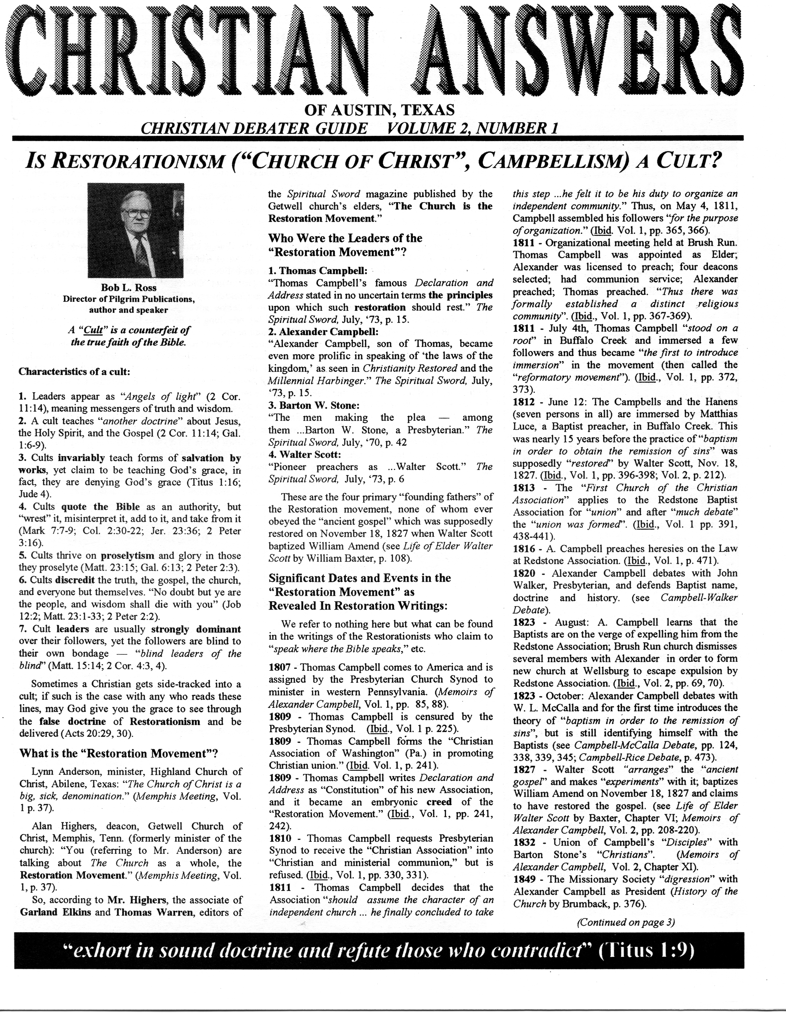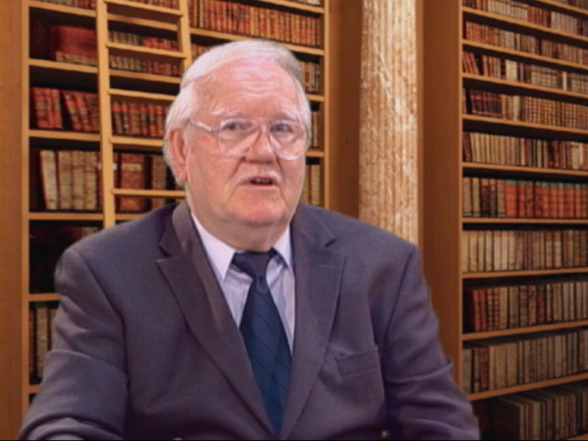

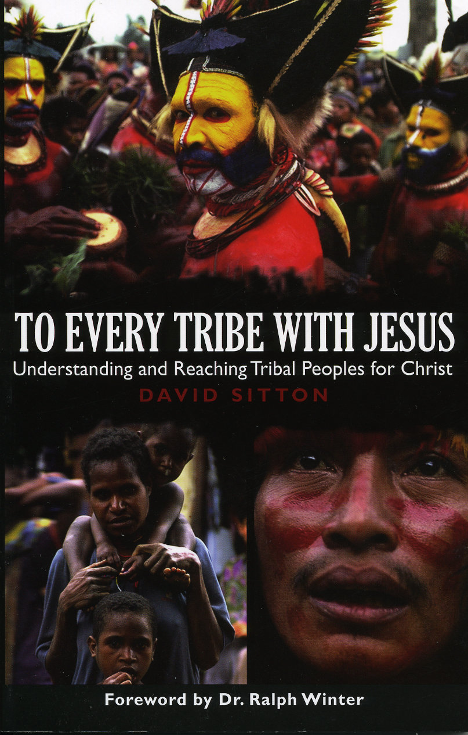



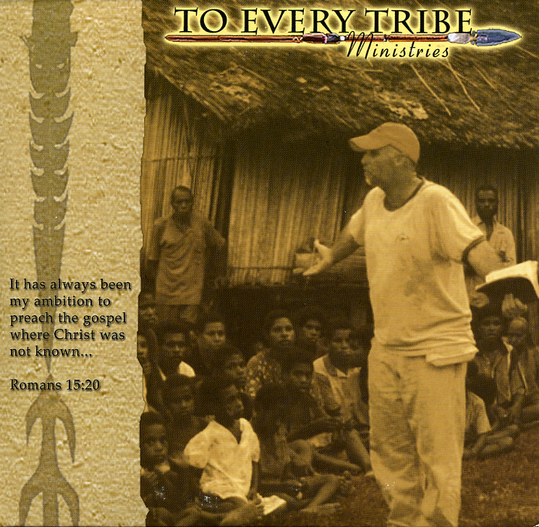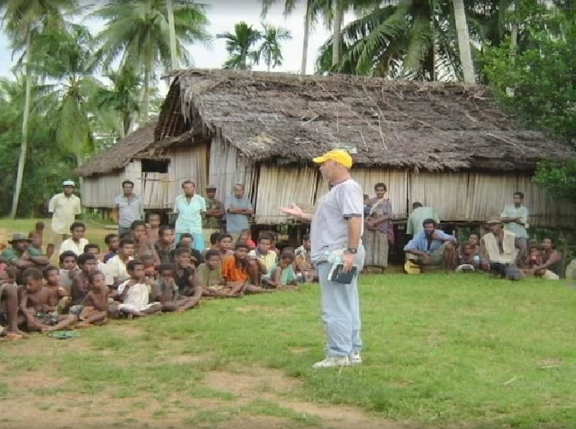
Christian Debater Guide
7
Christian Answers Order Form
IF YOU NEED MORE SPACE TO MAKE YOUR ORDER PLEASE USE A SEPARATE SHEET OF PAPER.
SUBTOTAL

POSTAGE AND HANDLING

TEXAS RESIDENTS ADD 8.25% TAX

TAX DEDUCTIBLE DONATION

How to place an order with Christian Answers of Austin, TX
1) Please indicate your full shipping/ mailing address.
2) Please include quantity, description and price.
3) We accept MasterCard and VISA. Attention: All of our credit card orders will be processed through Digital Media Productions. Please include your name, address, phone number, credit card number and expiration date with your order.
4) Please make check or money order payable to CHRISTIAN ANSWERS OF AUSTIN, TX
(we can only accept US funds).
5) Mail to : Christian Answers , P.O. Box 144441, Austin, TX 78714.
6) Foreign orders must be paid with an international money order (US funds only). Charges
are extra for foreign air mail.
Up to $30.00 $2.00
$30.01 to $50.00 $3.50
$50.01 to $75.00 $5.00
$75.01 to $100.00 $7.00
$101.00 and up 8%
Foreign orders 20%
PLEASE ALLOW 2 TO 4 WEEKS
FOR DELIVERY.

Quantity
Description
Unit Price
Total
Thank you for your order or donation.
It helps us pay our bills (II Cor. 9:7-12).
GRAND TOTAL
*Free copies of our new video catalogue are available upon request.
NAME:______________________________________________________
ADDRESS:___________________________________________________
CITY:______________________________________STATE:__________
ZIP:______________PHONE#: ( )_____________VISA [ ] or MC [ ]
CREDIT CARD:_____________________________exp. Date:_________
These two audio tapes (or CDs) are free with $25 order or donation (check boxes if you want them):

Sunni Muslims (AC-323)
Campbellite Doctrine (AC-126-42)

Hear experts and apologists analyze these topics (perfect for study groups or as a witnessing tool to share with others). You may choose any four of the 30 minute videos below for the single price of $6.00. Catalog identification is CATV. For example, if you wish to order Bahaism, “Church of Christ”, Mormonism, and Islam; list on order form as CATV= 1, 13, 8, and 2. Four videos on one VHS tape for one low price of $6.00. DVD copies of these topics are only available in increments of 4: #1-#4, #5-#8, #9-#12, #13-#16, #17-#20, #21-#24 only, with no variation, $6.00 each.
1. Bahaism (Dr. Frank Beckwith)
2. Islam (Dr. Samuel Shahid)
3. Buddhism (Steve Morrison)
4. Hinduism/Reincarnation (Mark Cass)
5. Roman Catholicism (Richard Bennett)
6. Jehovah’s Witnesses #1 (Larry Wessels)
7. Jehovah’s Witnesses #2 (Larry Wessels)
8. Mormonism (Robert McKay)
9. Word-Faith Heresy #1 (Dr. Michael Horton)
10. Word-Faith Heresy #2 (Dr. Michael Horton)
11. Seventh-day Adventism #1 (Wallace Slattery)
12. Seventh-day Adventism #2 (Wallace Slattery)
13. The “Church of Christ” (Bob L. Ross)
14. Liberal Christianity #1 (Morrison & Wessels)
15. Liberal Christianity #2 (Morrison & Wessels)
16. Atheism (Larry Wessels)
17. Nation of Islam (Wilford Darden)
18. United Pentecostals (Steve Morrison)
19. Unification (Moonies) (Morrison & Wessels)
20. Demon Possession (Dr. Thomas Ice)
21. Roman Catholicism #1 (Rob Zins)
22. Roman Catholicism #2 (Rob Zins)
23. The Da Vinci Code (Morrison & Wessels)
24. Darwin’s Evolution Religion (Dr. M. Girouard)

TOPICAL VIDEOS
Perhaps you’ve never thought about what it is like on the mission field. Now you can be there on the frontlines sharing the Gospel. Take a fascinating journey to New Guinea with Christian missionary David Sitton. David brings the Gospel of Jesus Christ to primitive, animistic native tribesmen. Inspiring.
DVD-34, $6.00 + S& H, (90 min.)
David Sitton in New Guinea.
FOREIGN MISSIONS: IN NEW GUINEA WITH DAVID SITTON
Two DVDs for the price of one!


LETTERS FROM THE FRONTLINE
To: Larry,
Please send me DVD-127 Debate with the Atheists. Keep up the great work! My check for $8.00 is enclosed. Thank you.
R.S. (Laguna Woods, CA)

Dear Larry,
Thanks again for continuing to send “Christian Answers.” Sorry that I have not said thanks already. Since my heart attack and mounting arthritis problems of last summer, I just have not had the energy to keep up correspondence. I appreciate your fine work and witness and will always remember your valiant stand. My finances in retirement are modest, so I cannot purchase items or send support checks as I would like to do. Perhaps eventually my personal finances will improve. Anyway, dear lad, keep up the fine work. In Christ Jesus, Sovereign Word & Redeemer.
G.P. (Canada)

Friends in Christ,
I am writing you from a Texas Prison near Palestine, TX. I picked up and read a couple of your newsletters recently and was impressed by what I read. Its very hard to get literature in here that isn’t from one cult or another. I find myself the most comfortable studying reformed theology so when I picked up Volume 2 Number 2 “Turn or Burn” by Spurgeon I was elated. A whole sermon by him in
black and white to read and chew on was refreshing. I also read your newsletter on King James Onlyism and would like to hear more like it. Please send me your newsletter so I can be prepared to give answers as you and your contributors are. I have no money so you’d have to front me the subscription. I’d really appreciate it. Love & Prayers.
J.T. (Tennessee Colony, TX)

Brother Larry,
Greetings in Christ our Savior! I just read your newsletter that a friend gave to me. Thanks for being obedient to the call. I am a Pastor in Lafayette, LA, a large Roman Catholic territory. There are 82 Catholic churches listed in our phone book. I have been a Pastor for 17 years and I am 44 years old). God Bless.
Pastor K.H. (Lafayette, LA)

Christian Answers,
I saw your program on television concerning Muslims and the misconceptions of the Quran versus the Bible. I would like to have the program with the scriptures concerning the nature of Christ and who and what He was. I would be more than happy to put a check in the mail and buy that from you. I sure appreciate your program. It is very interesting. God Bless you.
R.C. (Austin, TX)
8
CHRISTIAN ANSWERS
OF AUSTIN, TX
P.O. Box 144441
Austin, TX 78714
Phone (512) 218-8022
www.biblequery.org
www.muslimhope.com
www.historycart.com
Email: cdebater@aol.com
“exhort in sound doctrine and refute those who contradict” (Titus1:9)
Inside This Issue:
Topic: Foreign Missions

page 1: To Every Tribe (Part I)
page 2: Thoughts from Director
page 6: Ministry Update
page 8: Letters from the Frontline
Address Service Requested
Non-Profit Org.
U.S. POSTAGE PAID
Permit #1149
Austin, TX
Have you ever faced a challenge so great that you thought, “No matter how much I do, I don’t seem to even scratch the surface!”? This is how I have felt lately. Ministry to Muslims is not a piece of cake. The missionary movement can barely keep up, since the population of Muslims doubles every 20 years. Islam presents us with a threat, a challenge, and an opportunity that I’d like to talk to you about. The threat of Islam’s global agenda is not to be taken lightly, and terrorism is not the greatest threat! Islam has succeeded in pacifying the civilized world by exerting its financial influence over our educational institutions, by building mosques in North America, Europe, and around the world, and by launching an aggressive public relations campaign. Muslims have convinced the West that terrorists are not true Muslims, and that Islam is a peaceful religion. The challenge of reaching Muslims for Christ has never been more difficult. Islamic nations continue to actively suppress Christian missionary efforts and spread fear of persecution among potential converts. However, the biggest challenge for us is training national workers, including converts from Islam, to minister the gospel effectively to their people. Opportunities abound in spite of threats and challenges. There is a great hunger in the hearts of many Muslims, and they are responding to the gospel. In countries such as Kosovo, Algeria, Turkey and Iran, the number of converts has been unprecedented. As one missionary to Turkey put it, our biggest challenge is to respond to all the inquiries by Muslims. He estimates that 10% of the population of Turkey would come to Christ if they were given the opportunity.
George Houssney
President, Horizons International

Christian Debater Guide

Christian Answers’ Website CD is free for the asking.

